Liposomes and Pharmacology
Pharmacology is a branch of medicine that deals with everything drug-related. A drug is any medicine or substance that has a bodily effect when taken. Pharmacology was formally started in the early 1800s, however the exact date is not clear. Several scientists and doctors in the early 1800s experimented with substances, such as urea, plant drug called nux vomica, and arrow poison, and their effect on the body. Since the early 1800s pharmacology research and application has expanded tremendously. Now, the pharmaceutical industry in the United States is a whopping $446 BILLION dollar industry PER YEAR. Drugs costs anywhere from $300 million to $5 billion dollars to create. And it takes an average of 12 years to create a drug. The reason why it’s so expensive and time-consuming is because the Federal Drug Administration (FDA) wants to make sure the drug is effective (it treats the disease) and relatively safe (it does more good than harm).
Despite the hundreds of millions of dollars poured into the research of drugs, only about 8% of drugs are approved for human use by the FDA. This means that pharmaceutical companies are losing hundreds of millions of dollars for each failed drug. And there’s good reason to why a drug would fail. Say you have a heart condition and there’s this drug that can treat it. However, if the drug gets into the liver, then you will get liver failure. Because blood travels throughout the entire body and drugs travel through blood, you can image that it’s very difficult to get the drug to specifically target our heart and avoid the kidney. Most drugs are non-specific. Or image that you take a drug by mouth. When the drug is in its pill form, you have 100% of the drug. However, the digestive system breaks down the drug and by the time it gets into your blood, you may only have 10% of the drug. Non-invasive drug treatment has low bioavailability. Or let’s imagine the drug once it enters the blood stream. It’s swimming in the blood, getting to where it needs to go…when suddenly blood proteins swim by, attack, and destroy the drugs. This is especially common for larger drugs or drugs that are made out of protein. Drugs are generally not very stable in the blood. With all of these problems with drugs, we can now see why drug approval rates are so low…
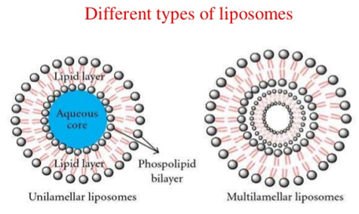
However, in the past 20 years, liposomes have come to the rescue. Liposomes are able to store drugs in their center. By doing this, the drugs are kept safer from the digestive system or blood proteins. The outer coat of the liposome can be coated with different molecules to help it target specific tissue. Liposomes can be made to different sizes for different purposes. Smaller liposomes are more likely to survive in the blood stream and bring the entire drug to the whole body. Larger liposomes are more likely to be targeted by blood proteins, which can be a good thing if the blood proteins have cancer. Liposomes can be made with different types of outer coatings or with different modifications to their outer coating for different purposes. The first FDA approved liposomal drive was in 1995. Now, in 2017, there are 15 of them in the public with many more on its way.
Reflection Questions:
Write down any words in the reading that you are unfamiliar with.

What did you think about while you were reading this text?

What did you picture where you were reading this text?

How does this text make you feel? And why?

If the text were to continue, what do you think it would talk about?

Key Points:
What are the problems with current drugs?

How can liposomes solve the problems above?

Conclusion Questions:
1. Do you think liposomes are natural or unnatural? Why?

2. Why are liposomes important? List at least 2 reasons and use evidence from the text.

Use the space below for group responses

